**Assignment-12.2:**

**Create a flume agent that streams data from Twitter and stores it in the HDFS cluster.**

Flume-ng:

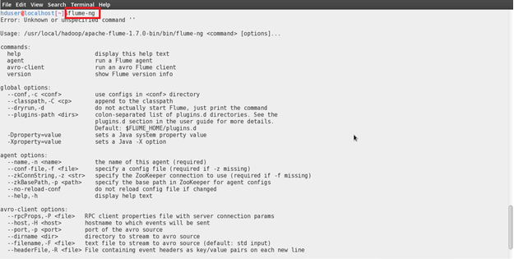

Twitter Apps: Creating Application In Twitter

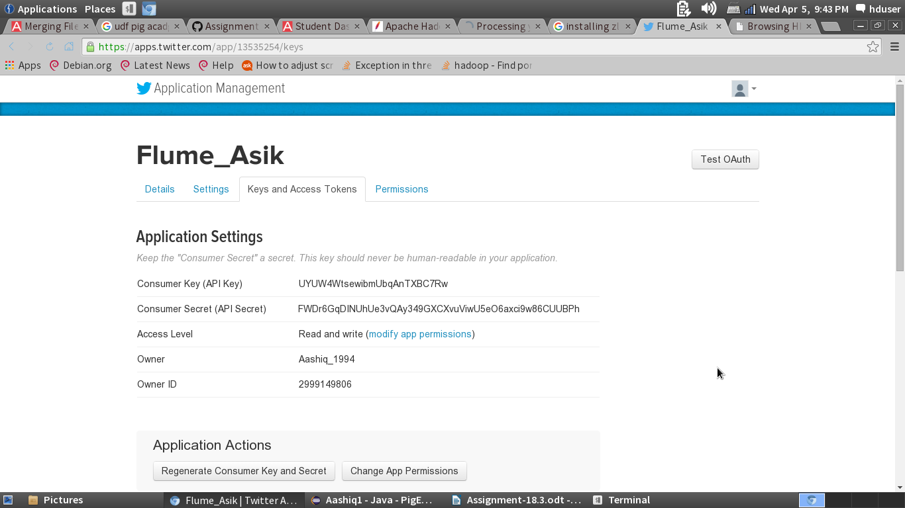

Configuration File:

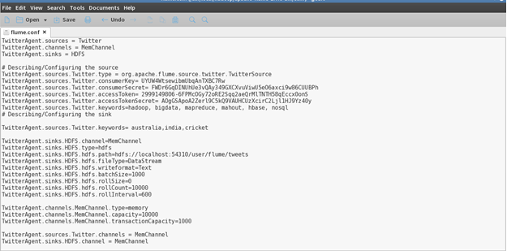

Command to fetch the data:

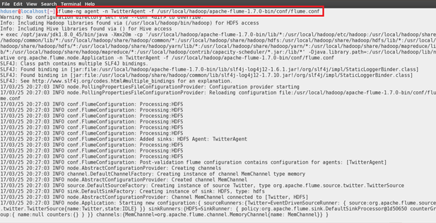

Processing the data:

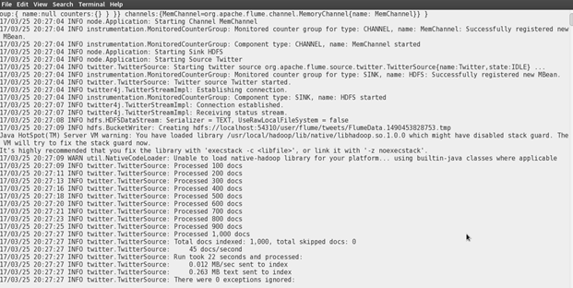

Data is Written is HDFS:

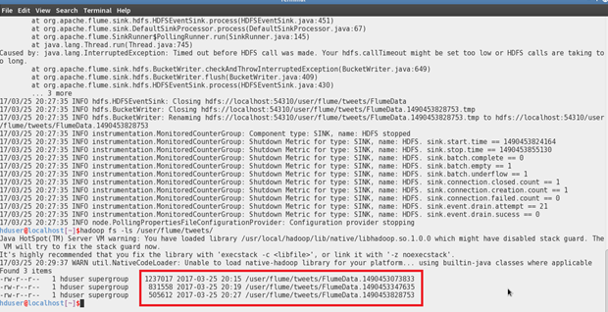

Web-UI:

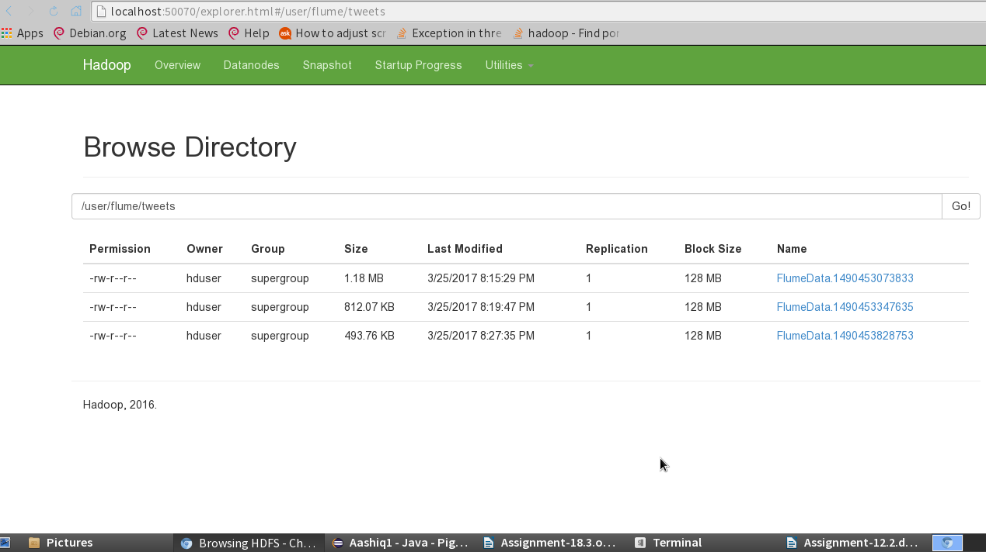

Sample Data:

